**Project Title: Public Transport Efficiency**

Problem definition:

The project involves analysing Public Transport efficiency and facilities data using IBM Cognos. A public transport efficiency project is a coordinated and organized initiative aimed at optimizing the performance, reliability, and sustainability of a city or region's public transportation system. The primary goal of such a project is to enhance the overall effectiveness and attractiveness of public transit options, thereby encouraging more people to use them and reducing dependency on private vehicles.

**Design Thinking:**

**1.Analysis objectives:**

To measure the on-time performance of public transport vehicles (e.g., buses, trains, trams) and also evaluating the number of passengers using the public transport system on a regular basis, analysing the trends in ridership to identify peak hours, busy routes, and seasonal variations.

**2.Data collection:**

* To obtain from provided data file containing PUBLIC BUS TRANSPORT information as per number of boardings per week.
* Collecting data for public transport efficiency involves gathering information on various aspects of the transportation system to assess its performance and identify areas for improvement.

**3.Visualization strategy:**

Visualizing for public transport efficiency is essential for clear communication and effective implementation. Here are some ways to visually represent such a strategy’s using bar chart, Pie chart, Heatmap, Histogram, Line chart, etc…,

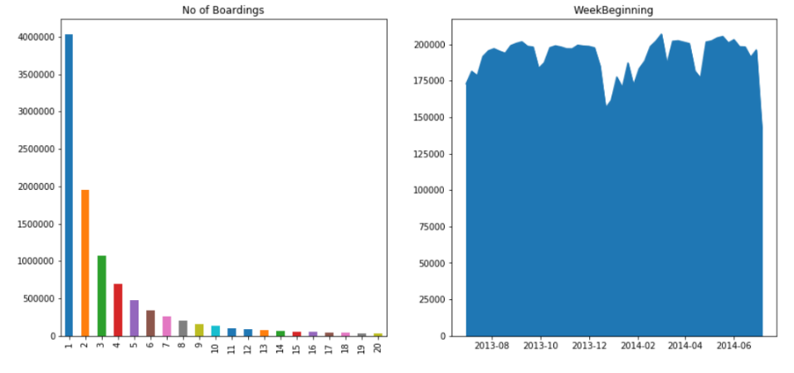

**4. Tools Required:**

* Google Co-lab
* Tableau
* Power BI

**5. Insight Generation:**

Generating insights for public transport efficiency involves analysing data to identify trends, patterns, and areas for improvement using descriptive analysis , time series analysis and predictive modelling. By following this, stakeholders can gain valuable insights into the performance of the public transport system, enabling informed decision-making and targeted interventions to enhance efficiency.